Date:27/01/2026

Change Hardware compatibility of a VM (Either by clone/create new one) which is already created and configured using vmware workstation.
AIM
To demonstrate Hardware compatibility of a VM (Either by clone/create new one) which is already

SOFTWARE REQUIRD
- A computer with Windows or Linux as Host OS
- Minimum 8 GB RAM (4 GB minimum works, but 8 GB recommended)
- VMware Workstation Player/Pro
- ISO file of Guest OS (Windows/Linux, e.g., Ubuntu)
- Internet connection

PROCEDURE
Step 1: Download VMware Workstation
- Open a web browser.
- Visit the official VMware website.
- Download VMware Workstation Player (free for personal use) or VMware Workstation Pro.
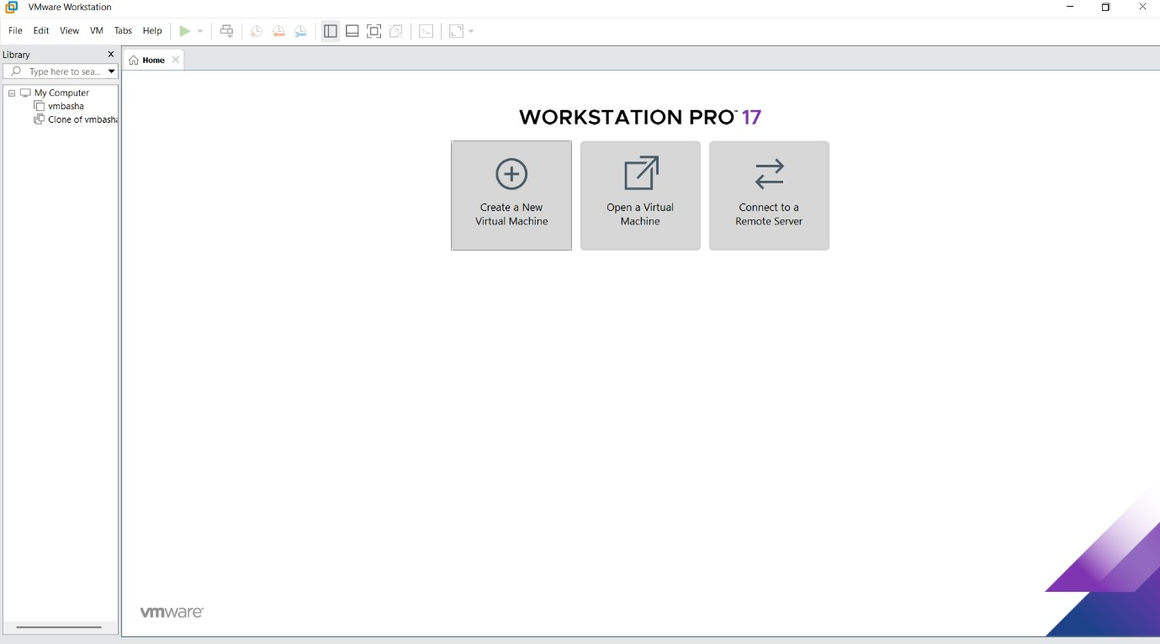
- Save the installer file.

Step 2: Install VMware Workstation (Type-2 Hypervisor)
- Double-click the downloaded installer.
- Click Next and accept the license agreement.
- Choose default installation settings.
- Click Install.
- Restart the system if prompted.
VMware Workstation runs on top of an existing OS, so it is called a Type-2 Hypervisor.

Step 3: Launch VMware Workstation
- Open VMware Workstation from the Start Menu (Windows) or Applications (Linux).
- The main dashboard will appear.

Step 4: Create a New Virtual Machine
- Click Create a New Virtual Machine.
- Select Typical (Recommended) and click Next.
- Choose Installer disc image file (ISO).
- Browse and select the Guest OS ISO file (Windows/Linux).
- Click Next.

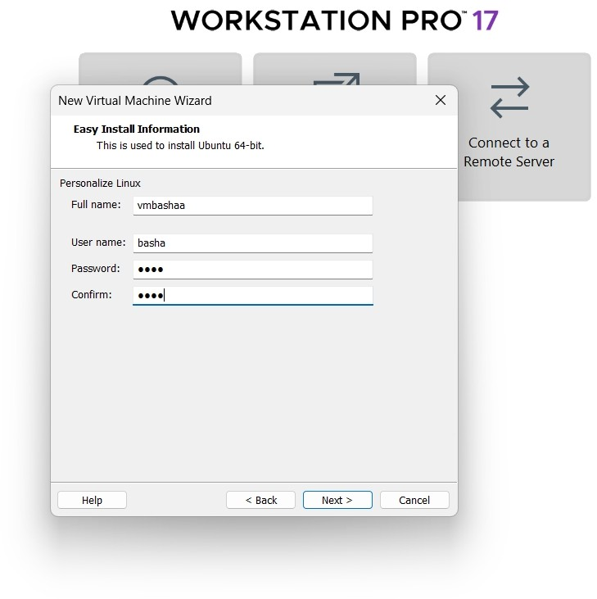

Step 5: Select Guest Operating System
- VMware automatically detects the OS.
- If not detected, manually select:
  - Linux → Ubuntu (or chosen distro)
  - Microsoft Windows → Appropriate version
- Click Next.

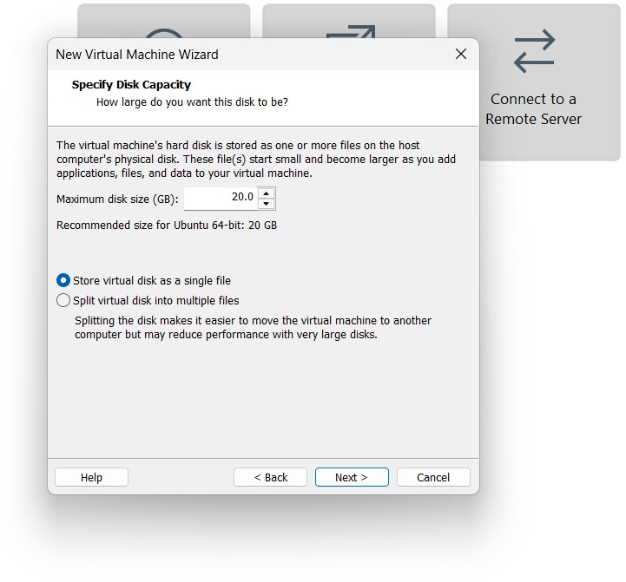
- ​

Step 6: Configure Virtual Machine
- Enter a Virtual Machine Name.
- Choose the location to store VM files.
- Allocate Disk Space (e.g., 20–40 GB).

Select Store virtual disk as a single file.
- Click Next.

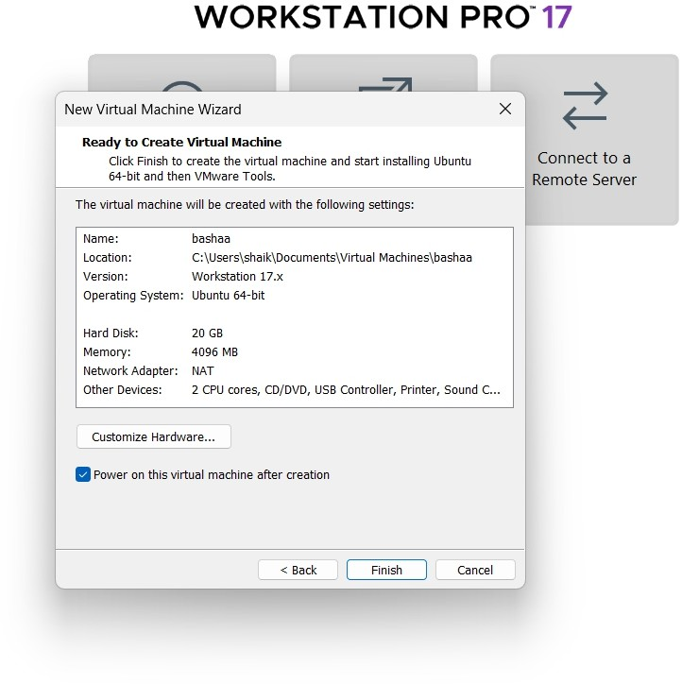

Step 7: Customize Hardware
- Click Customize Hardware.
- Set:
  - Memory (RAM): 2–4 GB
  - Processors: 1–2 cores
  - Network: NAT (recommended)
- Click Close, then Finish.

Step 8: Install Guest Operating System

- Click Power on this virtual machine.
- OS installation starts automatically.
- Follow on-screen instructions:
  - Select language
  - Create user account
  - Set password
- Wait until installation completes.
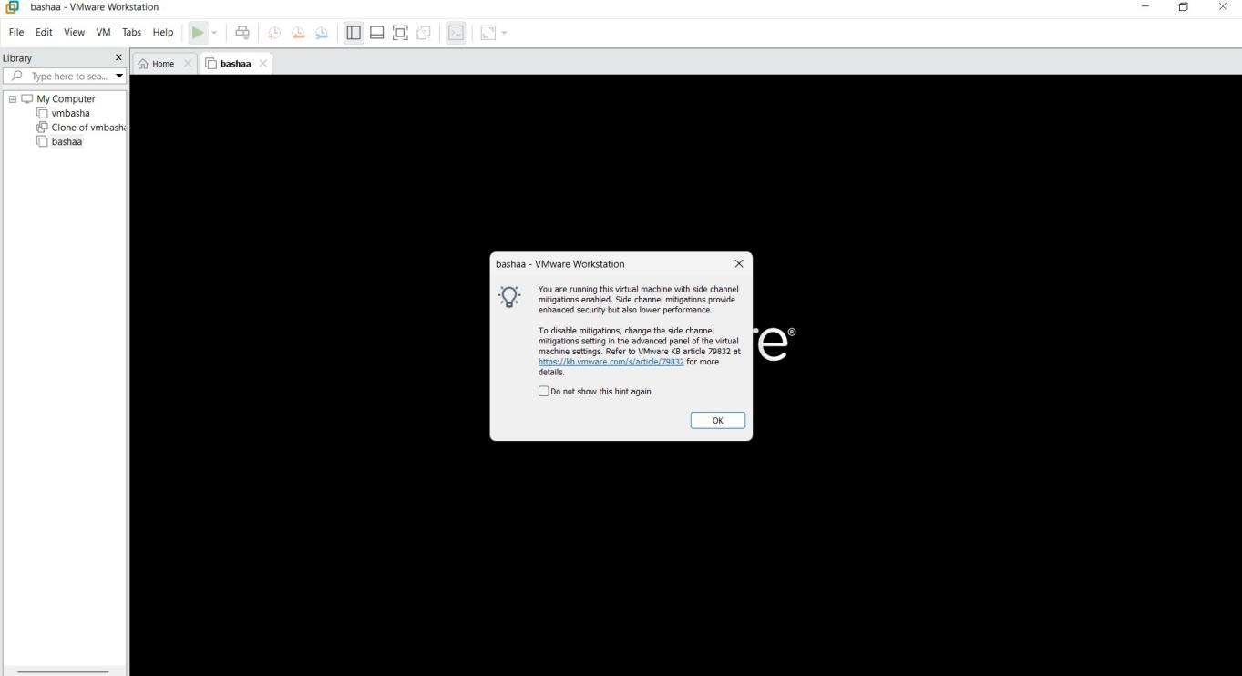

Step 9: Verify Virtualization
- Once OS loads, log in.
- Check:
  - System settings inside VM
  - RAM, CPU, and storage allocation
- The VM runs independently from the host OS.

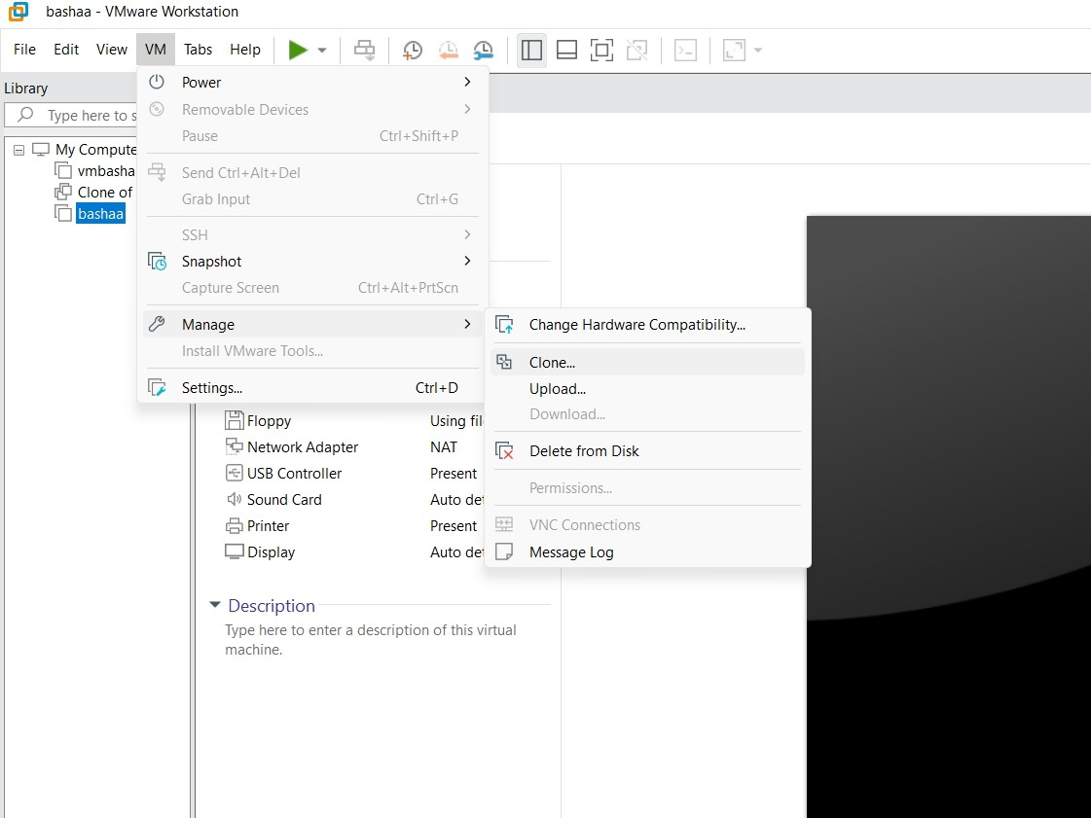

Output
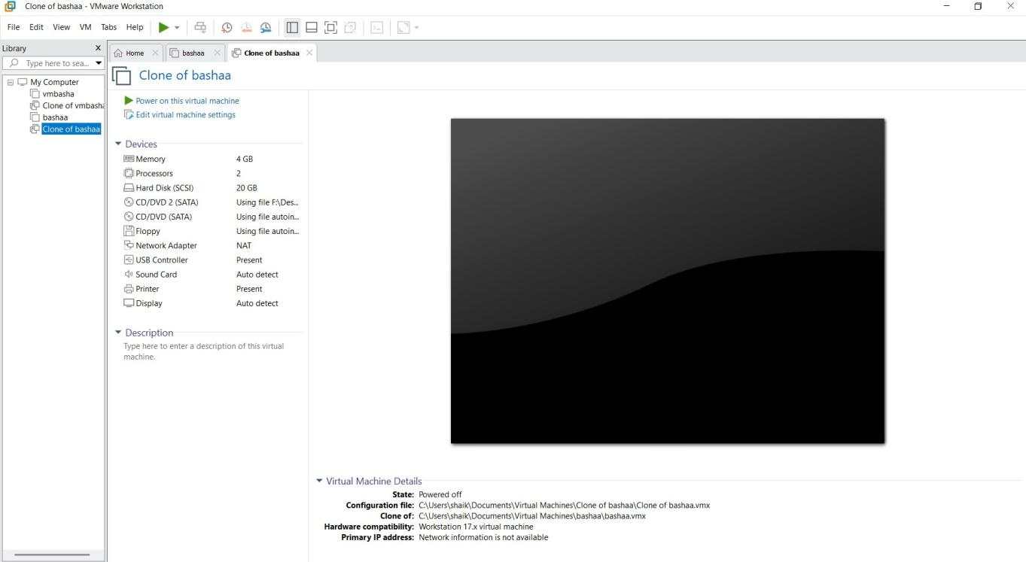
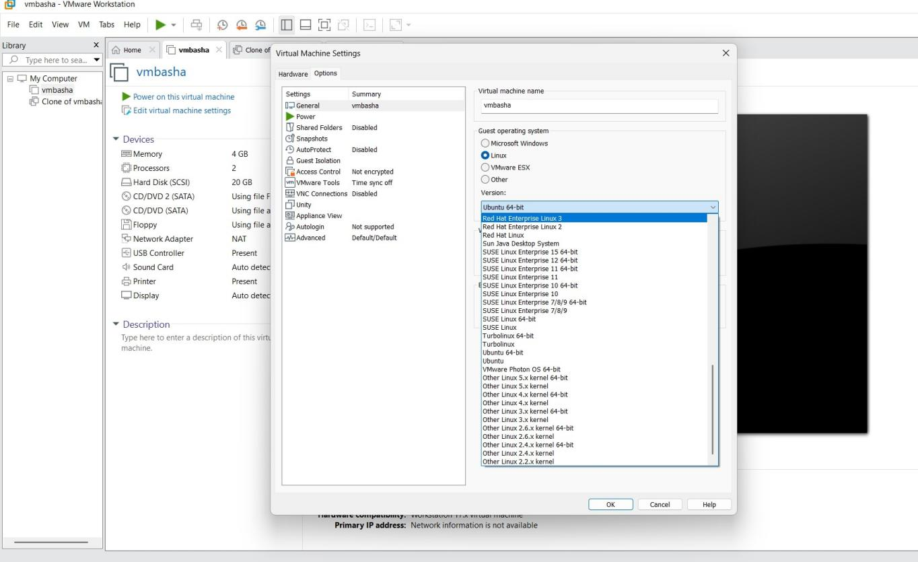

Result
Thus, Hardware compatibility of a VM (Either by clone/create new one) which is already

